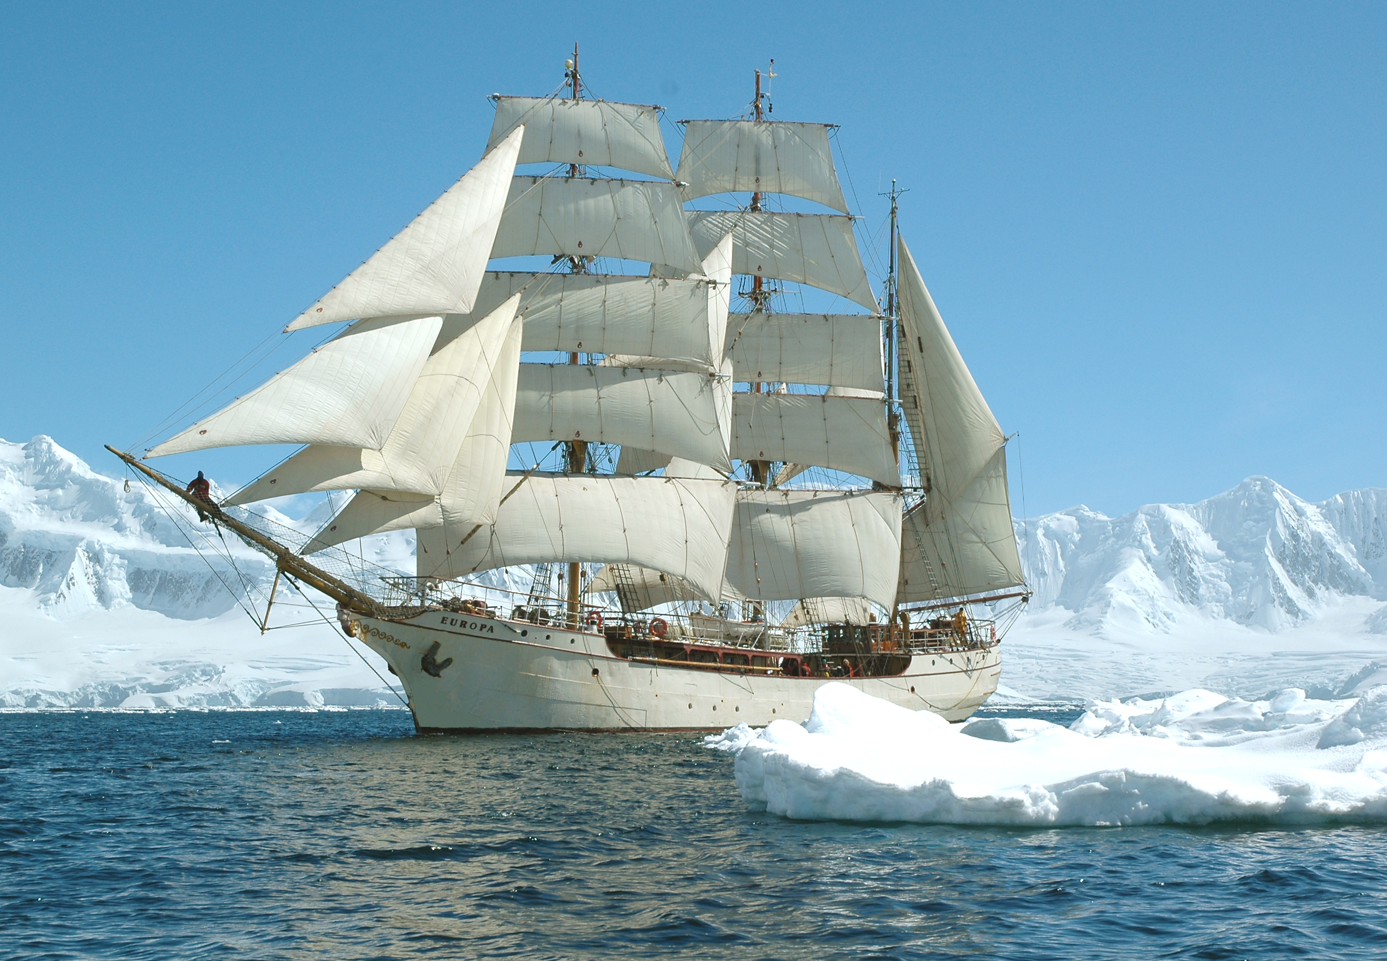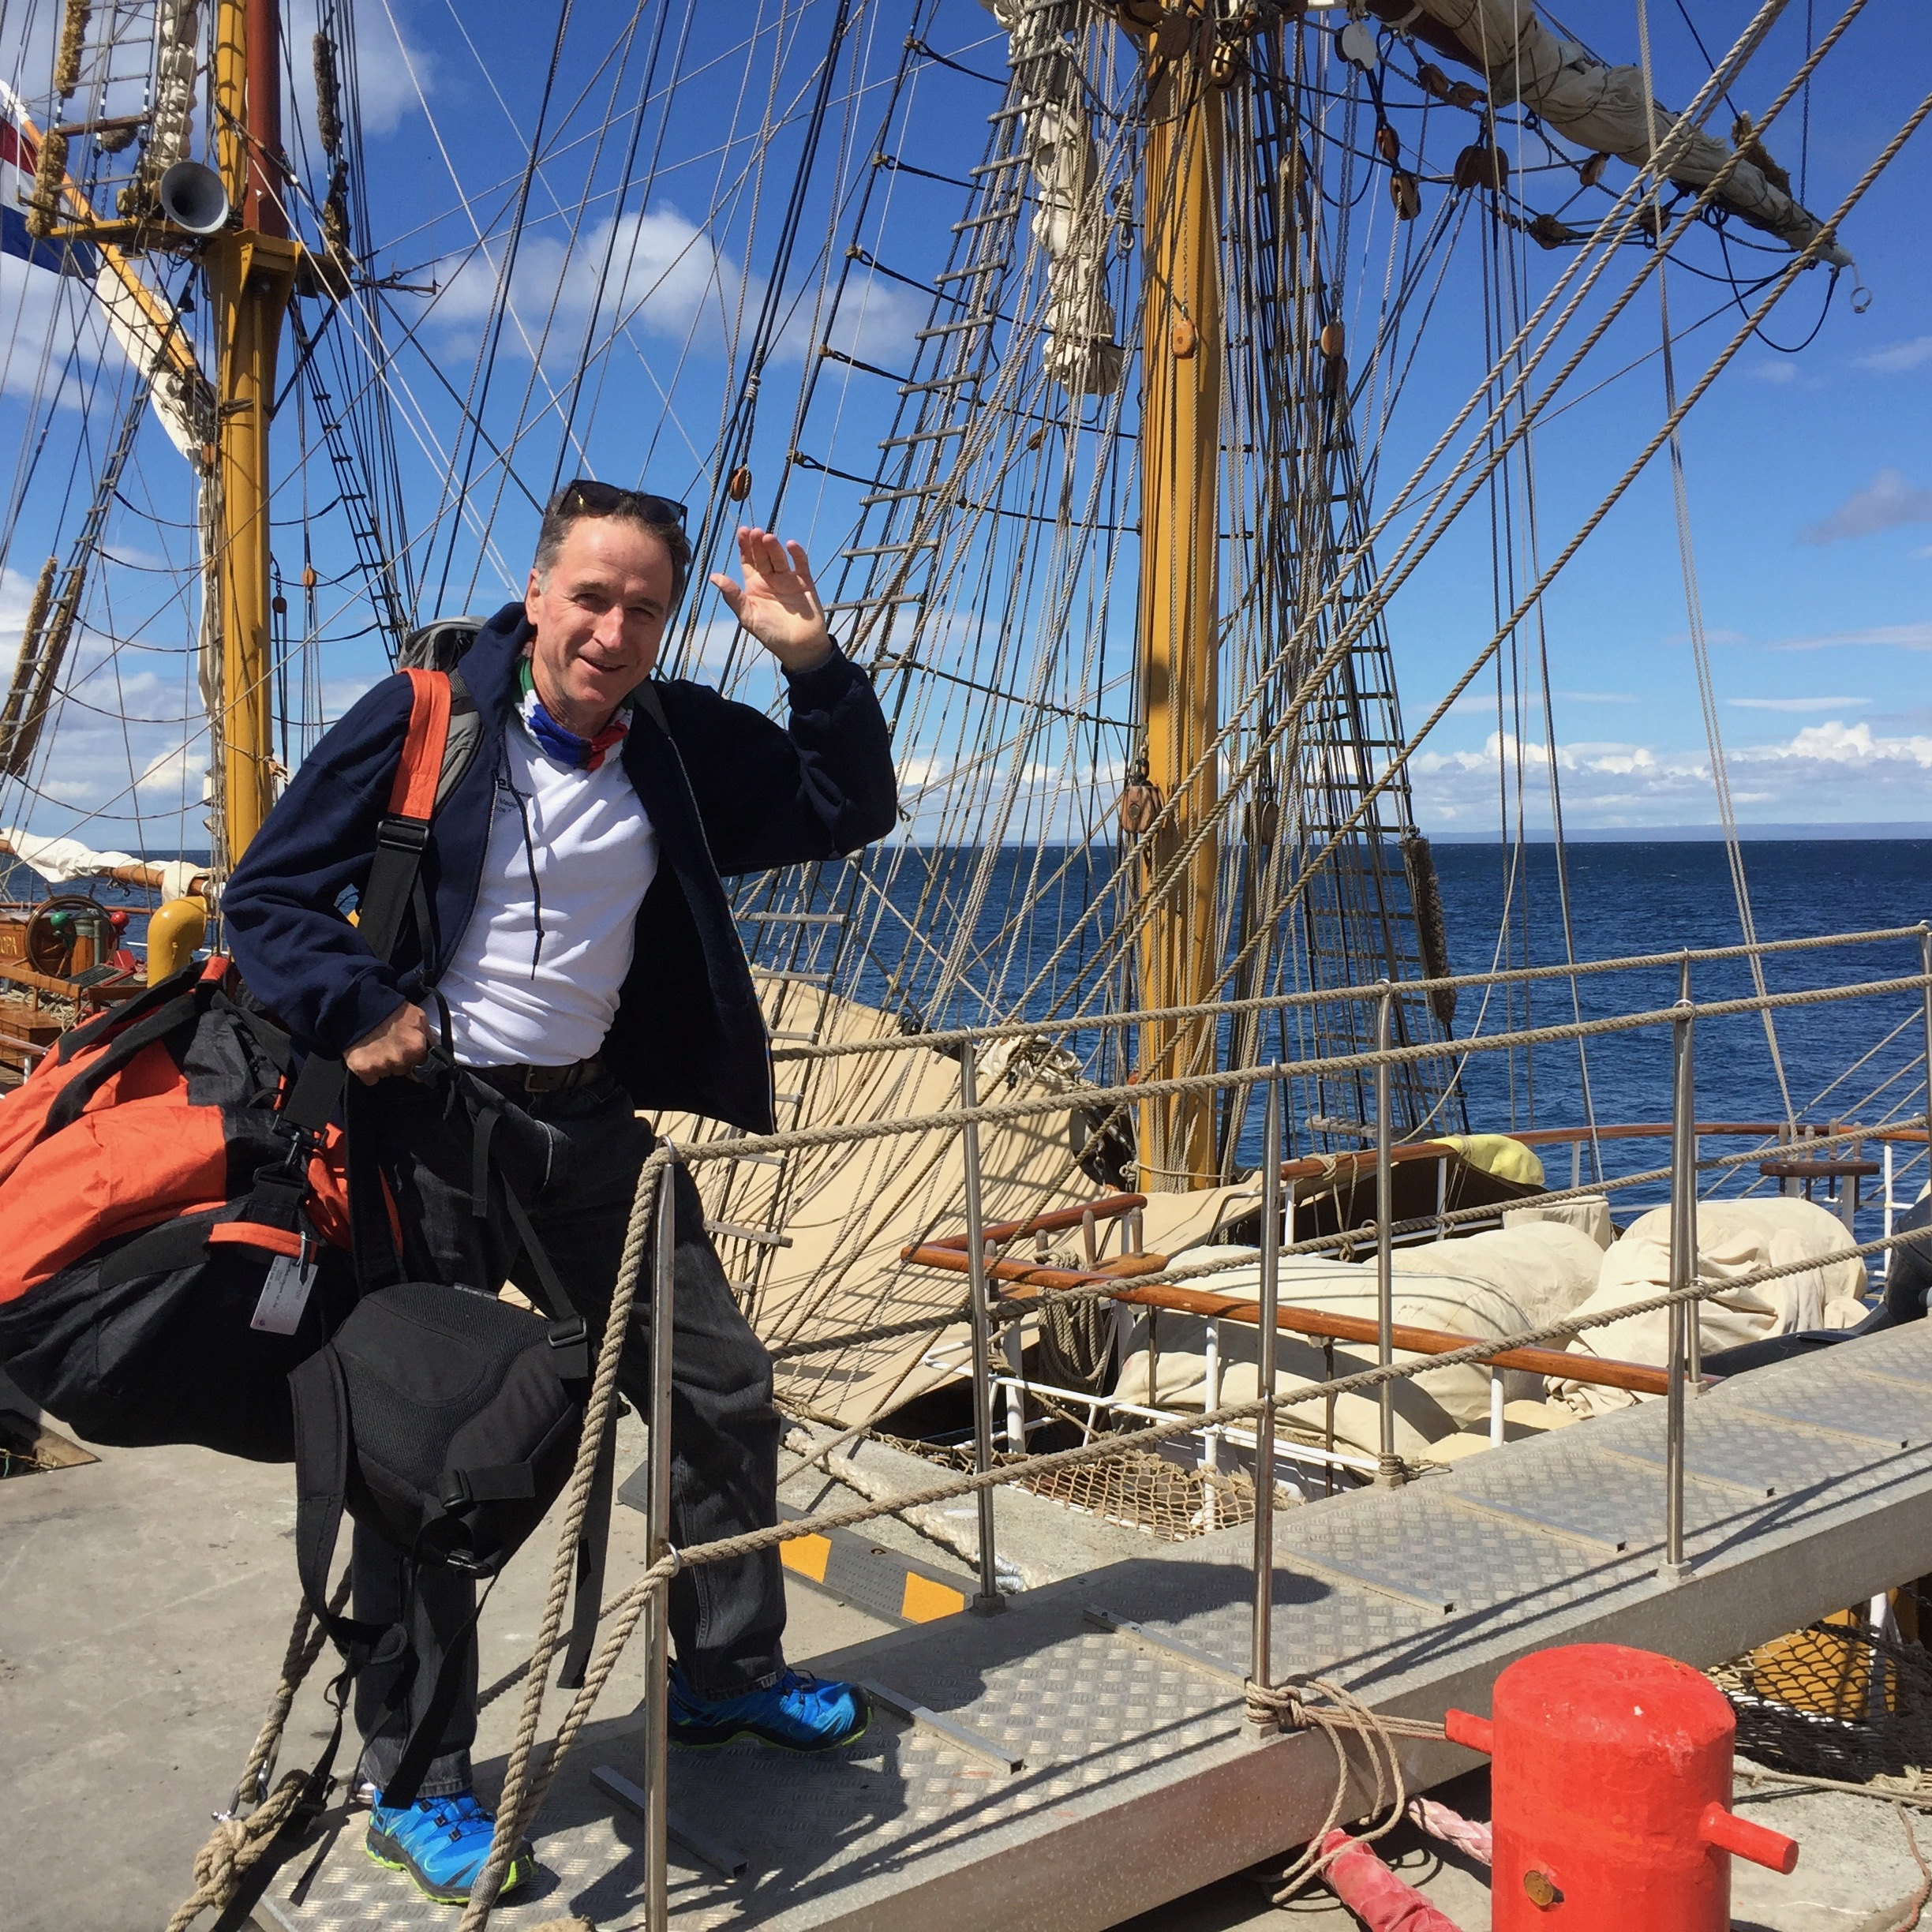

Antarctica on a tall Ship
Diary of a ship's surgeon

Bob Baigrie

Tues 3rd January 2017
8pm
91 Gnidia Rd
Rooiels

All are welcome

Its a bit late so as we can all have a drink on the deck
as the sun sets, allowing the room to darken for the slides.

Please reply if you can, for chairs, glasses etc.
robertb@surgcare.co.za
082 650 5671

