A prickly affair
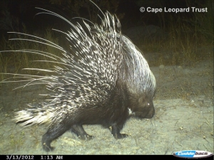
The porcupine (Hystrix africaeaustralis) is the largest rodent in Southern Africa. It is nocturnal and mainly eats bulbs, roots, fruit, bark and seeds.
Published: 28 August 2013
The advancement of remote-sensing camera trap technology has presented wildlife biologists with an ideal new tool kit to study secretive and nocturnal animals. But camera traps are not only a hit with scientists, the latest nature enthusiasts are farmers and private land- owners who are purchasing these high tech-toys to see which animal critters stroll by the tent when camping, who it is that inhabits the big burrow dug at the side of the road, or to just simply to record the diversity of animals on their farm or plot.
The CLT Boland Project team supports and encourages land-owners, private nature reserves and conservancies to buy their own cameras and to submit the data to the CLT and other databases. One such database is MammalMAP. The aim of MammalMAP is to update the distribution records of all African mammal species. Through collaborations with professional researchers, conservation organisations, wildlife authorities and citizen scientists across Africa, they consolidate all reliable and identifiable evidence (camera trap records, photographs) of current mammal locations into an openaccess digital database.
It was as a result of the efforts of citizen scientists from the coastal village of Rooi Els that a series of interesting camera trap images of Scott (BM12), one the collared leopards in the Boland, were recently obtained. The Rooi Els Conservancy raised funds for and purchased their own camera during 2011. They tested the camera in one of the conservancy members' garden for a few weeks, and then in June 2011 set off on an adventure to find a good spot to place the camera in a nearby kloof. A mere month later the Boland researchers received the Rooi Els Conservancy's first leopard photograph, and identified it as Scott, the dominant male leopard in the Kogelberg Mountains.
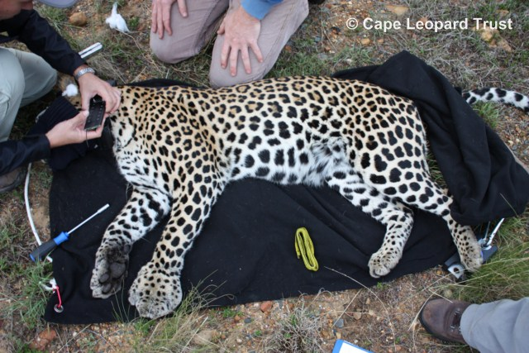
Scott being fitted with a GPS tracking collar in April 2013.
It is with great excitement and anticipation that e-mails from the conservancy members are received, hopeful of yet another image of Scott and his antics. The most recent download held a particular element of surprise. On arrival at the camera location on July 20th, Jill Lockley and Wolfgang Steinbach noticed lots of porcupine quills and some dried blood on the ground in front of the camera.
Very perplexed and intrigued they couldn't wait to take a look at the photos. The previous camera visit was on 8 May 2013 which meant there was almost 10 weeks' worth of data on the memory card. Surprisingly the first photo was that of Scott (9 May 2013 09:19 PM), and according to his posture, he seems to have been in a bit of a hurry.
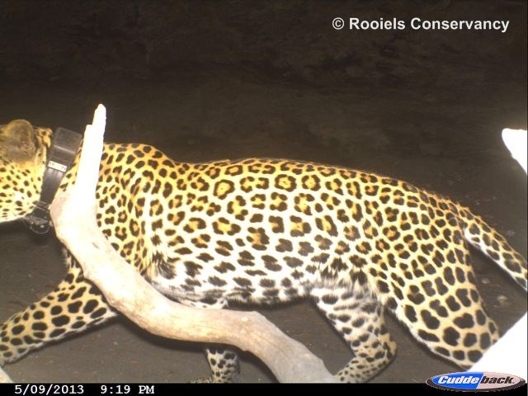
The very next picture, 5 minutes later, explains why – he was hot on the trail of a porcupine. The dust on Scott's coat and the sheer determination in his stance shows that he means business!
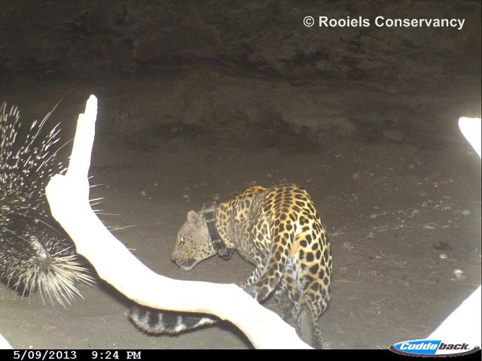
A mere 4 minutes later, another camera trap photo shows Scott to be the victor…
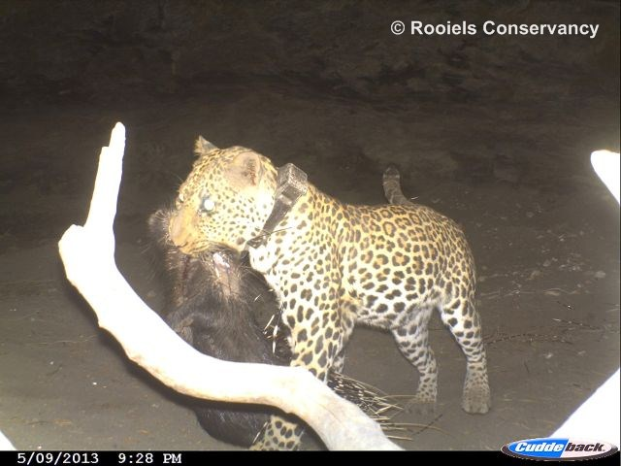
The diet of Cape leopards in the Boland mountains is currently being investigated using two complementary methods. Over the past three years the Boland team has collected over 150 leopard faecal samples (scats) throughout the study area. The contents of the scats are analysed in the lab and the prey animals are identified from bone and hoof fragments as well as hair found in the samples. Furthermore the GPS data of collared animals are used to find clusters of consecutive GPS points that plot closely together. These sites are visited and any prey remains found are recorded.
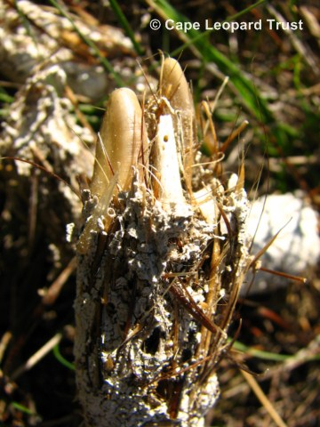
A leopard scat containing porcupine claws and quills.
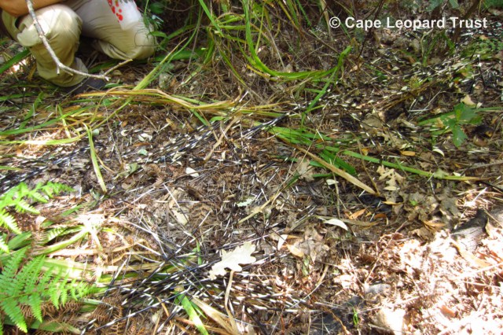
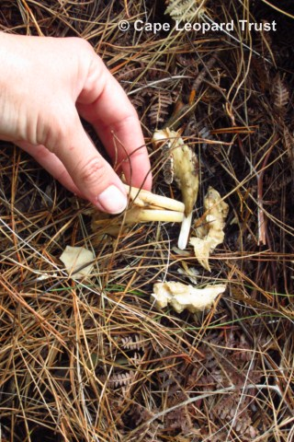
The remains of a porcupine after a leopard have finished eating. Only the quills, jawbones and some bone fragments typically remain.
Similar studies in the Cederberg show that 75% of the Cape leopard's diet in that region consists of klipspringer and dassie (less than 3% of the diet consisted of baboon). In contrast in the Boland it seems that porcupine and Cape grysbok are the most popular choices on the menu and form the major part of the leopards' diet.
To inquire about camera purchases, email: boland@capeleopard.org.za

