Biodiversity
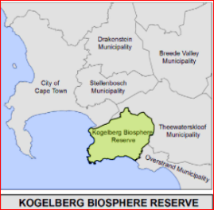
&
Conservation
A biosphere reserve is a unique kind of protected area which aims to conserve resources, species & ecosystems, monitor ecosystems, allow for scientific research, and finally, promote sustainable development in communities of the surrounding region.

Biosphere Reserves include areas of land & coastal ecosystems. Biodiversity represents everything that lives on earth. It is the fruit of billions of years of evolution, shaped by natural processes and the influence of humans.

Biodiversity is life and heals us. More than 70 000 plant and tree species are used in medicine. It gives us shelter. It feeds and clothes us. The consumption patterns of people in rich countries are the principal cause of biodiversity loss.

We need to preserve biodiversity. Human activity, population growth and climate change has greatly reduced biodiversity in ecosystems around the world.

One way each of us can contribute to biodiversity is to choose a more sustainable lifestyle. Education will help us recognise how we affect biodiversity. We need to understand that we are all part of the web of life. When one species disappears, others are at risk of disappearing as well.

Protecting our planet is in our hands. We may not be able to change the world, but we can protect the space we live in.

Nature conservation is the moral philosophy and conservation movement focused on protecting species from extinction, maintaining and restoring habitats, enhancing ecosystem services, and protecting biological diversity.

The most obvious reason for conservation is to protect wildlife and promote biodiversity. Protecting wildlife and preserving it for future generations also means that the animals we love don't become a distant memory. And we can maintain a healthy and functional ecosystem.

Regina Nikijuluw: “Community and its environment have been depending on each other since ancient times. They are inseparable. Community and environment are interdependent. Harmonisation of the two is inseparable, not only for the preservation of nature itself but also for the sustainable development of humans who inhabit the area. The union of the two is not only to turn the wheel of life but also the preservation of the biodiversity.”
Visit: www.rooiels.weebly.com for more information

