Fauna; Marine & Sea Life
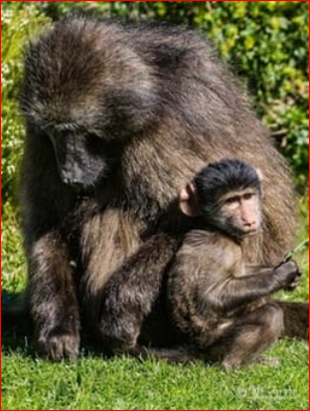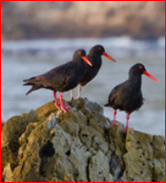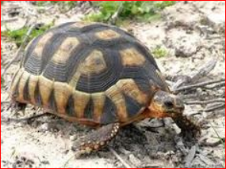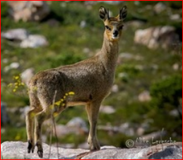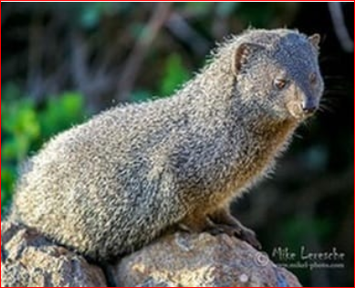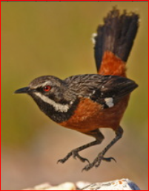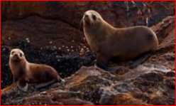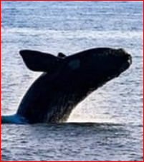
In Rooiels we live very closely with baboons, dassies, and mongoose, to mention a few.
From time-to-time we have visiting rooikat (Caracal).
At night if a shadow passes your door, sniffing out your braai, it is the small-spotted genet and there may be the larger Genetta tigrina nearer the river.
Klipspringer live on Klein Hangklip but are so well camouflaged that although fairly common you only occasionally spot them when they are standing up on the rocks. Cape grysbok are rarely seen but are known to have browsed in gardens in the past.
Smith's red rabbit was regularly seen on Rocklands Rd point, but it may have become rooikat breakfast as it was not seen for over a year. But a rabbit is back (seen in January 2016) in Klein Rooiels.
Smaller mammals include the Cape golden mole, the Cape dune molerat and a range of rodents including the little four-striped mouse and the quaint elephant shrews. We also have some alien larger mice and rat species that are a nuisance if our snakes and mongoose are not patrolling well.
Seals - are they Marine Life or land animals? We do have a colony living on Roman Rocks peninsular.
Tortoises are found all over Rooiels. This is the rooipens or duineskilpad, or angulate tortoise in the photograph.
The scorpions in Rooiels are mainly the brown variety with large pincers and a small tail. They can give you a nasty sting but are not fatal.
​﻿​﻿Rooiels has a wealth of avifauna. It attracts birders from across the world for sightings of the Cape Rockjumper which is endemic to the Cape mountain fynbos. We also have several pairs of breeding Black Oystercatchers, and in some years Verreaux’s (Black) Eagles are seen nesting on Klein Hangklip.

Rooiels is a seaside wonderland - a safe beach with a river feeding the lagoon and fascinating rock pools. Sea temperatures range between 12 and 23 degrees celsius (55-70F). The north wind brings the rain and also a warmer current for swimming. The south-easter cleans the air and brings in the cold currents reflected in the azure blue seas of summer.
​If you are lucky you can spot Bryde's whales, dolphins and occasionally Orcas all year round. From June to November the visiting Southern Right and Humpback whales are here. We have seals living out on the Roman Rocks. Cape Clawless otters eat crayfish in the sea and live in the river. You see their footprints, smell their scat, hear their high-pitched whistle at night, and occasionally you might even see them on the beach or in the Nature Reserve.
(For more detailed information, visit: https://rooiels.weebly.com/nature.html)

