MEDIAVERKLARING / PRESS RELEASE
#Overstrand4all

ISSUED BY:
Municipal Manager: Dean O’Neill
Tel: 028 313 8003 | mm@overstrand.gov.za
Overstrand Municipality

MEDIA ENQUIRIES:
Riana Steenekamp
Tel: 028 313 8043 | rsteenekamp@overstrand.gov.za

EMBARGO: Immediate release
29 September 2022
Load shedding affecting irrigation systems - PLEASE CHECK TIMERS‬‬‬‬‬‬‬‬
Several residents in the Overstrand who have high water usage have been warned of excessive consumption and alerted of possible water leaks by the Finance Department over the last few weeks.
According to the water meter readers, they encountered this anomaly in the Vermont area especially, where there are households with exorbitant water usage of between 40-100kl as opposed to their ‘normal’ usages of between 8-20kl.
When no leaks were detected, it was surmised that sprinkler systems could have been affected by load shedding. This would result in irregular timing when sprinklers re-start again.
The request is that all households who have their sprinklers on timers should please check whether load shedding affected the systems and result in high water usage.
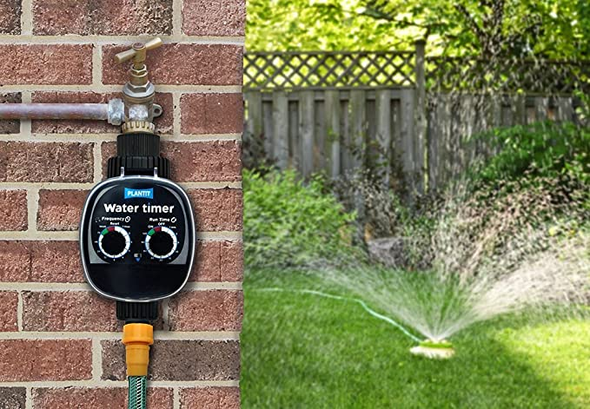
Feel free to direct any questions regarding exceptionally high-water bills to enquiries@overstrand.gov.za and be sure to visit your nearest municipal office to verify your account details. Alternatively, phone Kleinmond (028 271 8400 or 028 271 8465); Hermanus (028 313 8000 or 028 313 8196); Stanford (028 341 8500 or 028 341 8516) and Gansbaai (028 384 8300 or 028 384 8328).

END/EINDE
