DRAFT - Invasive Alien Plants of Rooiels and The Hack

Rooiels has a tradition of working hard to ensure that Rooiels remains natural. To do this we need to ensure that most of Rooiels retains its indigenous fynbos – as a source of seeds and as a habitat for all the insects, birds and other animals that call Rooiels home.

Invasive alien plants are a major threat to the fynbos. Originally introduced as plants to protect sand dunes, or as ornamental plants for gardens, these alien invasive plants have replaced the fynbos in many areas in the Overstrand. They are a threat not only to biodiversity and our natural landscape; they are also highly flammable and they choke wetlands and seriously affect catchment areas in the Western Cape. Alien invasive plants were a major factor in the Knysna fires. Some of the most widespread and problematic species are: Acacia cyclops (Rooikrans), Acacia saligna (Port Jackson Willow/wattle), the poisonous manatoka (Myporum), various pine species and certain grass species. In the wetlands bottle brush plants (Callistemon) are almost impossible to eradicate.

Rooielsers gather on the first Saturday of every month to work together on removing these plants, especially the Acacia cyclops. The Hack is a tradition that goes back decades and has been responsible for clearing almost all of the Rooikrans in the village, the most problematic of the alien invasive plants here. A report on the Estuary in 1981 indicates that more than 90% of the area surveyed had been invaded by rooikrans. Today there are only a few stands of these trees but they keep appearing across the village! And after a fire the seeds sprout again. The seeds are able to lie dormant for decades! So that we expect our grandchildren to still be “hacking”.

We urge all Rooielsers to join the Hack at 0800 (summer) and 0830 (winter). It is good exercise and a way of protecting our heritage. At 10.30 tea and delicious eats are served so it is also a social gathering where you also get to meet and catch up with fellow Rooielsers. PLEASE would ALL, old and young, join us. There are different tasks for all ages.
Contact The Hack Convenor, Dick Lockley at Tel 083 454 3964 jillanddicklockley@gmail.com

The plants that currently cause most harm in Rooiels are pictured below:
Rooikrans (Acacia cyclops)
Rooikrans is a rounded evergreen shrub or small tree with narrow leaves and bunches of twisted seed pods

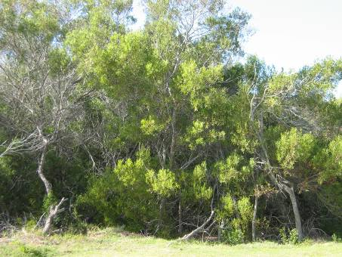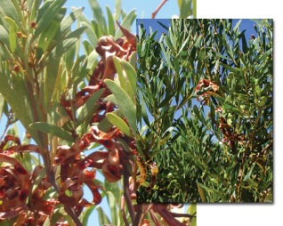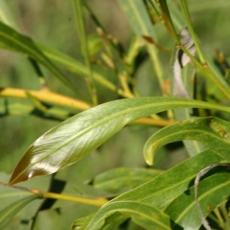

Fountain Grass (Pennisetum setaceum)
