Rooiels History
Coordinates: 34°18′05″S 18°48′59″E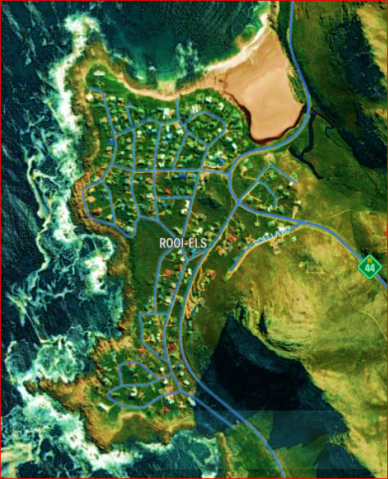
Rooiels (Afrikaans equivalent of red alder) is a settlement in Overberg District Municipality in the Western Cape province of South Africa. It was declared a township in June 1948 and is situated 5 km north of Pringle Bay, on the eastern shore of False Bay. It was named after the farm and river by this name.
It is situated beside the Kogelberg Biosphere Reserve and is itself a registered conservancy. The town roads are narrow, un-tarred and without street lights. Klein-Hangklip mountain dominates the village. Animals that may be noted are chacma baboons, rock hyrax, small antelope, African clawless otters and occasionally caracal and leopard.
Rooiels is a small town in the Cape Winelands region of the Western Cape Province of South Africa. Rooiels is a residential community, and a holiday destination, with many opportunities for outdoor sports.
There is a moderate number of permanent inhabitants, many of whom are retired. The local baboons roam the area frequently and should not be fed. It is on the eastern shore of False Bay, just to the south of the mouth of the Rooiels river, and below the Klein Hangklip. There is a very pleasant little beach which is fairly sheltered from south west swells, and is generally safe for swimming. The Rooiels river flows into the bay at the south end of the beach, and is usually only inches deep and a pleasant place for kids to play.
The town is quite exposed to the south east wind in summer, which can be unpleasantly strong, but is often mild and keeps the place cool. Winter can be beautiful, if the wind is light and the weather sunny, and when the wind and waves are up, the surf pounds on the rocky shoreline and throws spray high into the air. It is a pleasant place to get away from the city for a few days, or to enjoy a quiet vacation for a week or so at almost any time of the year.
(Visit: http://rooiels.weebly.com)

