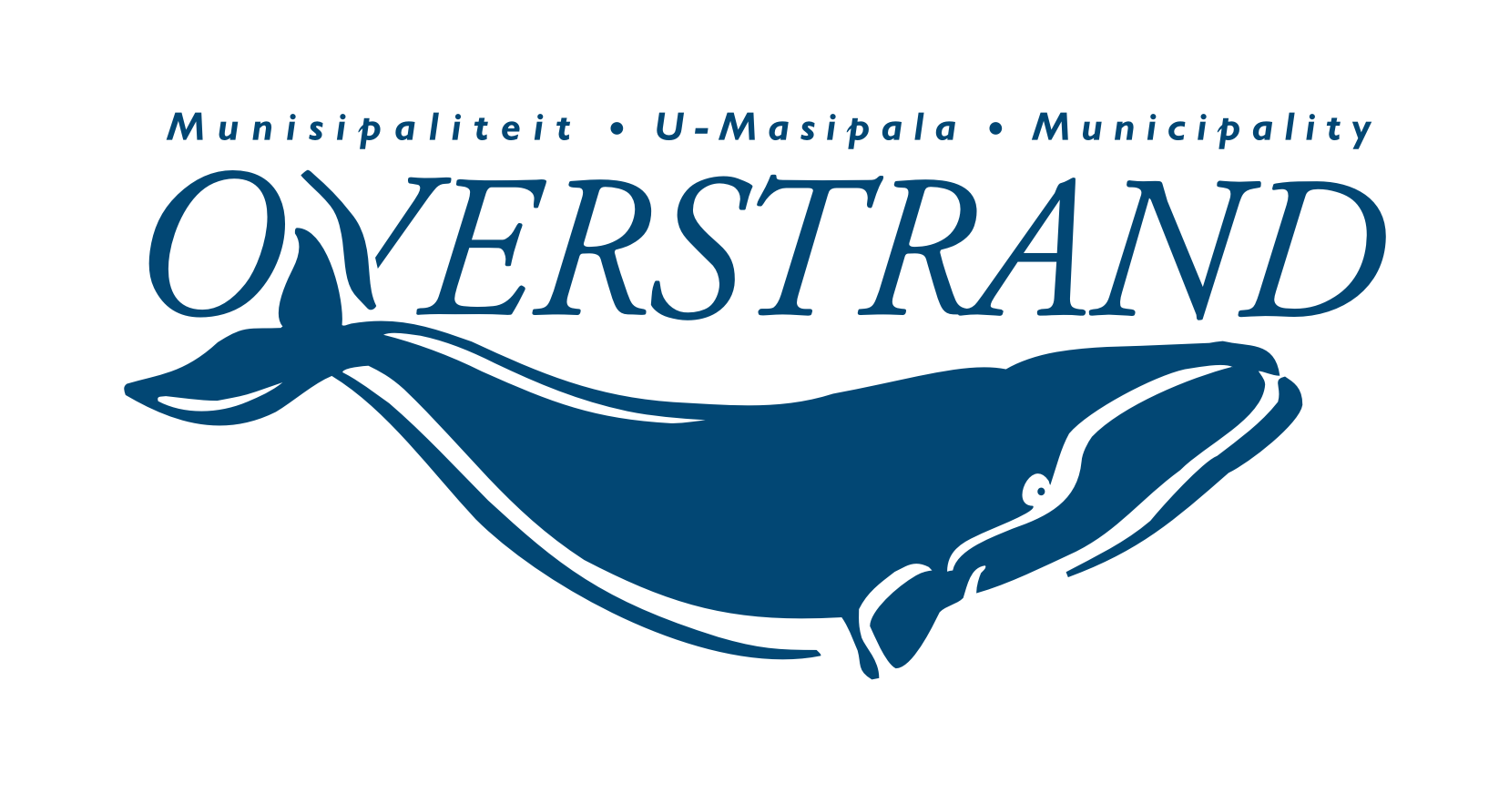
MEDIAVERKLARING / PRESS RELEASE

ISSUED BY:
Municipal Manager: Dean O’Neill
Tel: 028 313 8003 | mm@overstrand.gov.za
Overstrand Municipality

MEDIA ENQUIRIES:
Riana Steenekamp
Tel: 028 313 8043 | rsteenekamp@overstrand.gov.za

EMBARGO: Immediate release
16 August 2022
Inspirational women shine
The lovely sunny winter’s day on Saturday, 13 August 2022, was met with joy by the spirited women who have positive ‘can do’ attitudes and who go the extra mile. They are the ones on who everyone in their respective communities rely and they attended a special breakfast hosted by Overstrand Executive Mayor, Dr Annelie Rabie and Municipal Council as part of Women’s Month celebrations.
Residents were asked to nominate remarkable women in their organisation or neighbourhood to be honoured at this Inspirational Women’s Day event.
The occasion was officially opened with a prayer by Cllr Ronald Nutt, followed by the lighting of remembrance candles to honour all the mothers and special people in our lives who have passed away; including those who died during the covid pandemic.
As usual, Nelson Kanunu sang the National Anthem beautifully and the poem recited in Xhosa by Zola Tokota was very strong and emotional – this shows that passion does not know language or barrier.
During her speech Mayor Rabie raised a glass to all the outstanding women in the Overstrand who help others – “we all have experienced this; every so often and during different stages in our lives when we most need it, there is a woman who crosses our path who gets us moving forward again.”
She encouraged everyone to keep their sense of humour, to look after our planet and to look out for one another. “If you notice there is suffering next door or in the work place, make time to cross the road; because sometimes all we need is a friend to lean on.
Mayor Rabie thanked her Mayco members, the Council and Personal Assistant, Tosca Korver, for contributing to such an enjoyable and memorable experience.
The Boy choir from Zwelihle, the Young Brothers, sang “Vuyisana nabantu besifazane/celebaring women”, and it was perhaps the most fitting way to end the glorious morning.
Issued by:
Overstrand Executive Mayor, Dr Annelie Rabie

END/EINDE

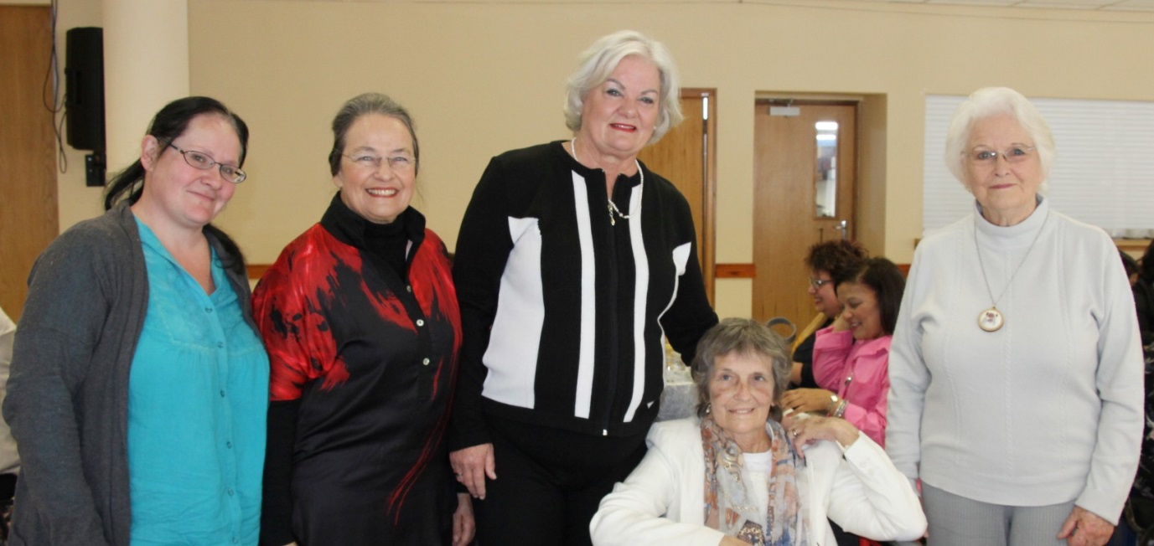
Cornelia van Niekerk, Charlyn Vosloo, Mayor Annelie Rabie, Sandy Waddingham and Dr Anina Lee at the Inspirational Women’s Day Breakfast.
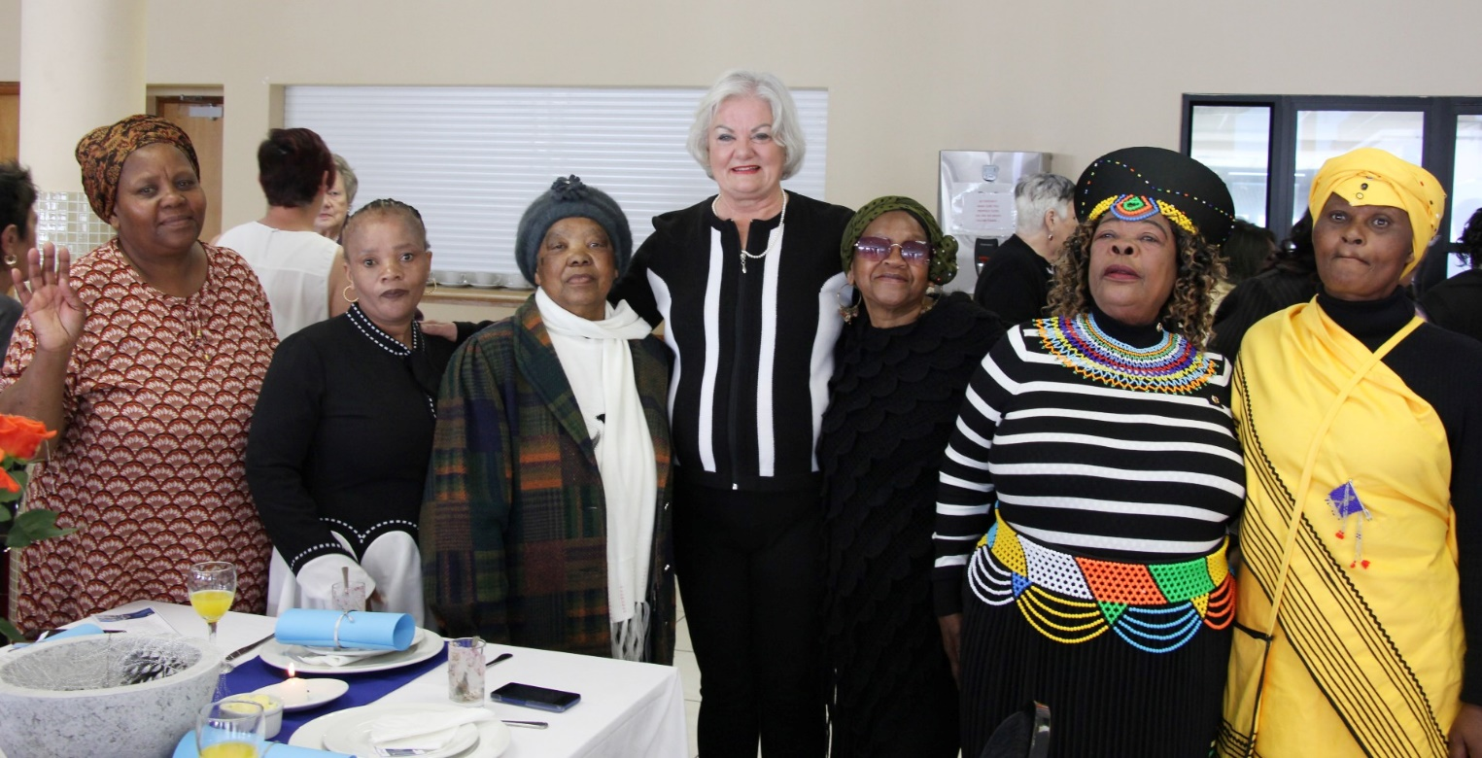
Mpoetsi Madolo, Sheila Hempe, Myrtle Alam, Mayor Annelie Rabie, Winnie Nywebeni, Paulina Gwebani and Thami Bandeza at the Inspirational Women’s Day Breakfast.
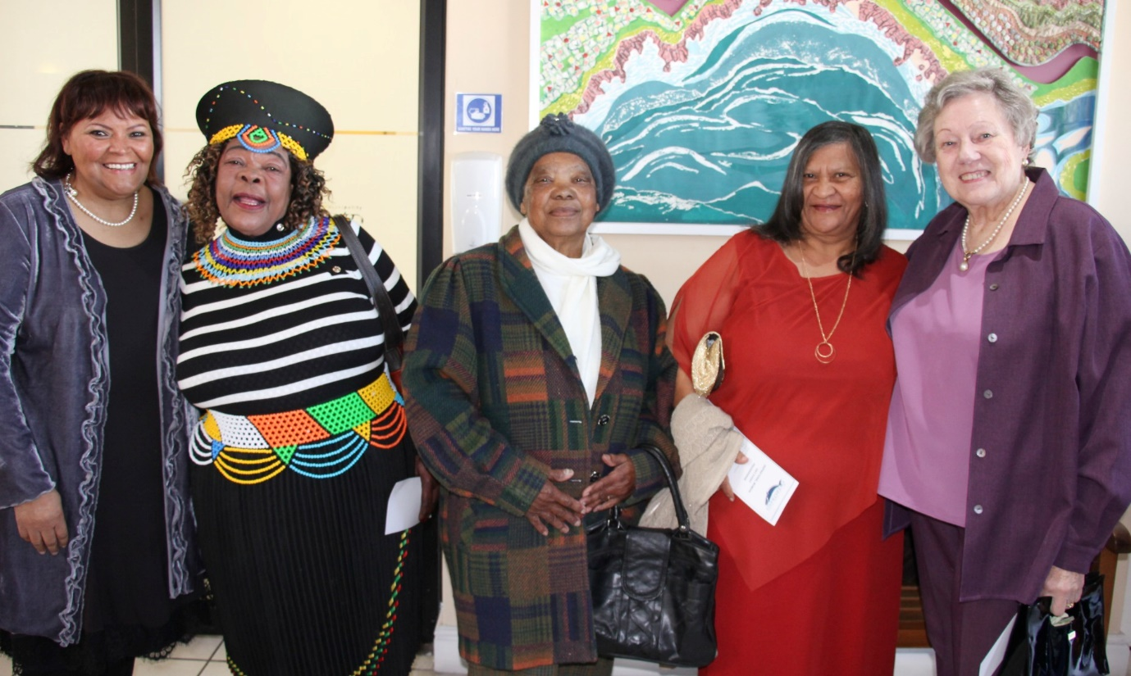
CELEBRATING SPIRITED WOMEN Joan Daries, Paulina Gwebani, Myrtle Alam, Loretta Veldsman and Corrie Gerber at Mayor Rabie’s Inspirational Women’s Day event.
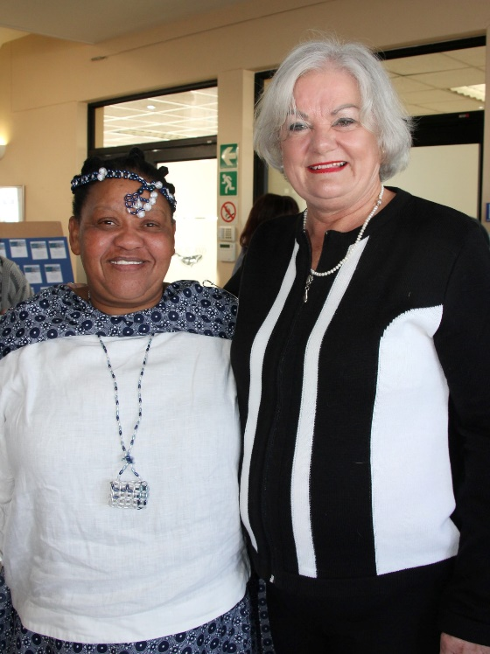
Hannie Morgan and Mayor Annelie Rabie at the Inspirational Women’s Day Breakfast.

