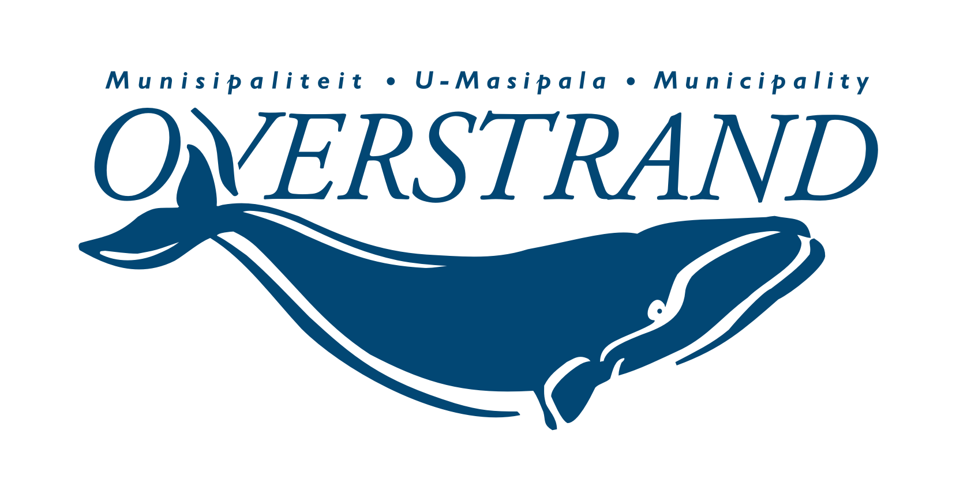
MEDIAVERKLARING / PRESS RELEASE
#Overstrand4all

ISSUED BY:
Municipal Manager: Dean O’Neill
Tel: 028 313 8003 | mm@overstrand.gov.za
Overstrand Municipality

MEDIA ENQUIRIES:
Riana Steenekamp
Tel: 028 313 8043 | rsteenekamp@overstrand.gov.za

EMBARGO: Immediate release
19 October 2022
OVERSTRAND WILL SALUTES ITS FALLEN HEROES ON 13 NOVEMBER 2022
Remembrance Day, informally known as Poppy Day, is a memorial day observed every year on 11 November, (or on the nearest Sunday to that date), to commemorate the end of the First World War on 11 November, 1918.
On Sunday, 13 November 2022, we will be joining the rest of the world in remembering those who have served and sacrificed, with the annual Remembrance Day Memorial Service.
The service is organised by the local Seagull Shellhole of the MOTHs in collaboration with the Overstrand Municipality, and will take place at the Cenotaph at the Old Harbour in Hermanus at 11:00. If attending, you are requested to be seated by 10:30.
Individuals who wish to lay wreaths can phone Karen Dickens on 067 360 9020.
All welcome to attend.
END/EINDE
